www.christianworldmissions.org

MARCH 2015
Prayer Notes & Ministry Opportunities:

Friday, March 20
Sedalia MO, 1st UMC
Women’s “Night

Saturday, March 21
The Big Event; MSU Maroon Volunteers at CWM Outreach Center;
Construction & Landscaping

Sunday, March 22
Southaven, MS; Southaven 1st UMC
Morning Concert

Saturday, March 28
2-5 pm – Straight-Up Saturday
(Monthly Neighborhood Ministry)
CWM Outreach Center

Sunday, March 29
Poplarville MS; 1st UMC
5:30 pm – Lenten Concert

Weekly Local Ministries:
Mon, 5:30pm –7:30 pm
Home Bible Study – Starkville
Lee Ann Williamson, leader
Fri, 6:30am – 7:30am
Men’s Prayer Breakfast
Cecil Williamson, host
CWM Outreach Center

Looking for a Mission Opportunity?
Join one of our International missions, or
Gather a team and join us for a week of construction in our Outreach Center!

Pray For Our International Partners:
Feb – Mar – J.K. Udeze in Nigeria and Joseph Otsin in Ghana – conducting follow-up training for lay pastors and visiting all recently established churches

Pray for Ganesh in Nepal, Ghuna in India, and Asif in Pakistan – all three countries experience on-going persecution of Christians. But the Gospel advances and the Kingdom grows!

See our website for event details:
http://www.christianworldmissions.org/news-and-events/ministry-eventsmissions/

To schedule a ministry event, order resources or join us on a mission trip:

Contact:
leeann@christianworldmissions.org
lori@christianworldmissions.org
info@christianworldmissions.org
cecil@christianworldmissions.org

I’ve been bragging on you! And I’m taking my lead from a 13 year old!

Do you remember ever telling your buddies how great your mom was? I brag on her all the time now, but as a 13-year-old? Why, she didn’t learn anything until I was in my 30’s!

Well, you know how hard parenting is, but the kids who come to our Straight-Up Saturdays (Monthly Neighborhood Outreach) are just regular ol’ teenagers.
Or, maybe they’re not!

In February, I was blown out of the water when I was talking to 13-year-old twins, Shawn and Shay, and their 12 year old brother, Dewaylon. I asked where their mom was; she was at her job, sitting with an elderly shut-in. I probed a little more and asked if they got to spend much time with her, expecting, in my narrow, middle-income worldview, that they would roll their eyes and say something warm and wonderful, like, “Are you kidding me?”

But they blew me out of the water! They said, “Oh, yeah! We do everything with our mom! We love to be with her!” I was curious about this amazing mom, so I asked if there was a possibility I could meet her, and sure enough, one quick call, and she agreed to come as soon as she got off work.

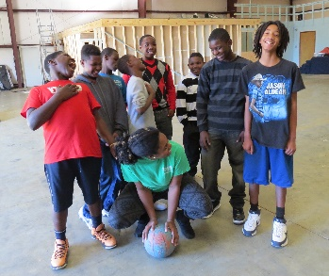
I learned quickly why they want to be with her. She loves them! She grinned with pride when I talked about them. No wonder her kids brag on her!

We brag on you, too! To the families we’re getting to know in the neighborhood, to our international partners, to one another, and even to our mama’s! We love you! We appreciate you! YOU are making a difference!

Smiling and thanking Jesus,

