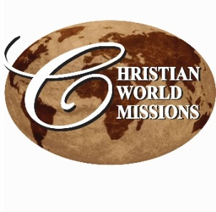
PRAYER NOTES & MINISTRY OPPORTUNITIES:

VOLUNTEER MISSION GROUPS:
Aug 10 – MSU Wesley Foundation Construction Crew
Aug 11 – MSU Service DAWGS Construction Crew

WEEKLY LOCAL MINISTRIES:
Wednesday, beginning Aug. 19, 5:45 pm
Bible Study: “Living Life by Faith in Him,” led by Lee Ann & Jean Ferguson
1st UMC Starkville

Thursday, beginning Aug. 20, 6:30 pm
Home Bible study, hosted by Lee Ann
205 Winterset, Starkville
The Minor prophets

Friday, 6:30 am
Men’s Prayer Breakfast
CWM Outreach Center, Cecil Williamson

Daily, Mon – Thurs, Beginning Sep 28
3:30 – 6:30 pm, 6-8th graders
Youth Community Explosion
CWM Outreach Center

Tuesday, beginning Sep 29, 6:30 pm
For parents of YCE program and others
“Parent 2 Parent”
CWM Outreach Center

UPCOMING
Aug 24-27 – Ghanaian pastor,
Joseph Otsin visits Starkville area

October: Training of 20 new pastors begins in GHANA AND NIGERIA in advance of church planting program in Feb/Mar 2016

Oct 8 – Dinner Theater, “A Night Under the Stars” CWM Outreach Center
Fund raiser; call for ticket info

Oct 9-10 – Clergy Spouse Retreat, Mississippi Conference, Brandon, MS

Oct 17-18 – Calvary UMC, Stockton, IL
Women’s retreat and Sunday services

CHRISTMAS CONCERT SEASON
Nov 29 – December 23 –
Don’t wait! Book yours now!

Looking for a Mission Opportunity?
Join one of our International missions, or Gather a team and join us in completing the construction in our Outreach Center!

See our website for event details:
http://www.christianworldmissions.org/news-and-events/ministry-eventsmissions/

To schedule a ministry event, order resources or join us on a mission trip:

Contact:
leeann@christianworldmissions.org
lori@christianworldmissions.org
info@christianworldmissions.org
brittany@globalcl.org

P.O. Box 985, Starkville, MS 39759
September 2015

What was the last thing you saw, did, or experienced that made you think, “Wow, this is worth keeping! This is something I need to share with my grandchildren!”

A number of years ago, my dad passed along a real treasure to me. It had come to him from one a parishioner early in his ministry. For years, I was allowed to look at it only occasionally, and was only permitted to touch it when I was old enough to understand how precious and fragile it really was.

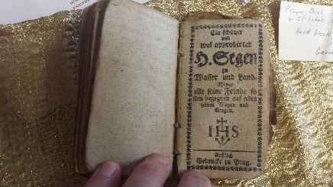
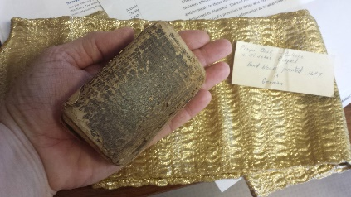
Have I piqued your interest? My daddy gave me a tiny, German prayer book which was printed in 1647. It has been wrapped in brocade cloth and kept in a felt-lined mahogany box for as long as it has been in our family. I can’t read a word of it, but it is a great treasure to me.

Out of curiosity, I recently searched for its monetary value, expecting far more than I found. It went something like this:
Cost of appraisal/antique specialist: $25
Sale value of German prayer book: $80
True Value of this treasure: PRICELESS

I started doing some thinking. It would be hard for me to quantify the value of the ministry you and I share. We might add up the dollars spent for pavilions, pastor salaries, wells, orphanages, training, and equipment. We could total the amount of money given to support CWM over the last 45 years. We could even total the number of people who have been reached through evangelistic crusades, leadership training seminars, youth rallies, and church plants. But none of that would be the real value of the lives that have been saved and changed forever.

On August 31, I received a call from one of our regular supporters. She and her husband were preparing their wills, and they had decided to leave a bequest to CWM and one of our international partners. She explained that God had clearly directed them in this decision because we are “sharing the Gospel and people are being saved, healed, and delivered.”

Your gifts are priceless, achieving far more than their simple monetary value. You are giving life. Thank you, friends. You are helping mine the richest treasure of God’s Kingdom.

Praying and preparing,
Lee Ann Williamson

