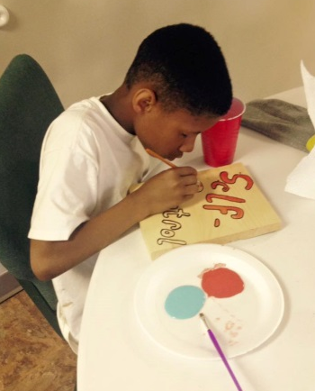
In Starkville, Mississippi, our youth recently donated school supplies, wrote notes, and made special wall art for a sister after-school-program that has had several break-ins since January.
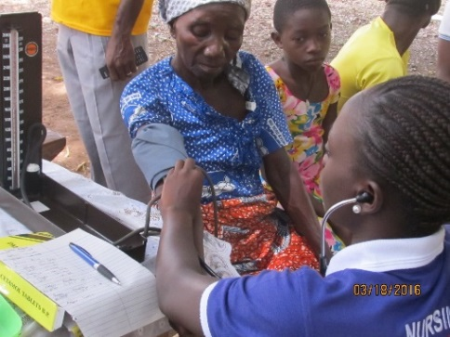
In Ghana, hundreds were served in free medical
clinics during the recent church-planting
crusades, and five new churches were
established in the Sunyane District in March

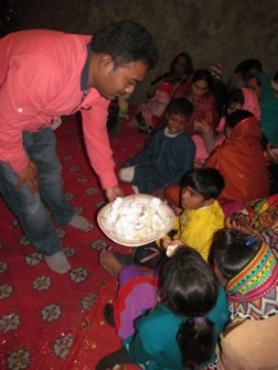
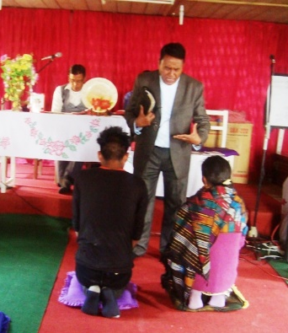
In Nepal, regular outreach in several small
villages, caring for the sick, helping with earthquake damage, providing food, school fees, etc. – has led to many people coming to Christ. This former Hindu couple was baptized and received their first communion on March 19.

In Pakistan, Catch the Holy Fire Ministries regularly feeds widows and orphans and helps brick workers suffering from fires, floods, and virtual slavery to their employers.

The reality is that, just like the weeds in our yard, the needs that face us just keep coming back – or coming again and again. Next week, I doubt that the guy from across the street will come back to mow, but the need will still be there.

I’m eternally grateful that we can depend on you. I pray that you will ask the Lord to continue to increase your supply so that you can continue to do more and more for His Kingdom.

Please take a look at the prayer needs this month – our ministries across the street and around the world are stepping out in faith to share the Good News. Pray that every need is met that they might serve without the daily concern of provision.

Take a look out your window – how is God blessing you this day? Can you pass it along to someone else? He’s given you everything you need for life and Godliness!

Blessings and love,


