
P.O. Box 985, Starkville, MS 39759
PRAYER NOTES & MINISTRY OPPORTUNITIES:

WEEKLY LOCAL MINISTRIES:
Men’s Prayer Breakfast
Friday, 6:30 am
CWM Outreach Center, Cecil Williamson
Youth Community Explosion
Daily, Mon, Tues, Thur (Begins Feb 8)
CWM Outreach Center, ends May 6
Summer YCE: June 6 – July 15

APRIL
14 – Drive-In Dinner to Buy a New Ride
Fund-raiser to replace burned-out van
$10/meal; pick-up at St. Joseph Catholic, Starkville, MS
16-17 – Eureka, IL, UMC
Weekend of Renewal & Concert

30 – MAY 1 – Ladies’ Day Apart and Sunday Services, Picayune, MS FUMC

PRAYER NOTES:
- India – funds for salaries on the Gospel Friends campus
- Starkville – funds for a new van in Starkville (approx.. $15,000)
- Starkville -- Funds to complete construction of community outreach center (approx.. $110,000);
- Pakistan – funds for completion of church and for children’s school fees
- Cecil Williamson – still recovering from back surgery
- Tiffany Ward – co-director of Youth Community Explosion; expecting her first child in July
- Rosella Goddard – office assistant; expecting 2nd grandchild any day – mom has high blood pressure concerns
Local volunteers needed!
Construction, Mentoring & Tutoring, Organization Projects

See our website for event details:
http://www.christianworldmissions.org/news-and-events/ministry-eventsmissions/

To schedule a ministry event, order resources or join us on a mission trip:

Contact:
leeann@christianworldmissions.org
lori@christianworldmissions.org
info@christianworldmissions.org
brittany@globalcl.org
tiffany@globalcl.org

April 2016

Happy April! Hope you’re enjoying the beauty of spring that pops out every day this time of year. I don’t know why, but every single year I am surprised by how absolutely stunning spring is, as if it’s an entirely new blessing, something I’ve never seen.

I looked out my office window this morning to see a stranger mowing our lawn – now that was a genuine blessing! I figured he was from the lawn care business across the street, but since this was the first time it’s happened, I walked out to meet him. Sure enough, he had a new mower and just wanted to try it out. What???? Why, thank you! (It could be that he just got tired of looking at our weeds, but I’m going with his generosity!)

What if we all took that approach with “tools” we have, just wanting to “try them out” for the good of a neighbor?

To that neighbor who offends – Give from His bottomless well of forgiveness;
To the widow living alone – Time is a commodity we have forever – give 30 minutes;
To the struggling single mom – Help with a bill or with babysitting;
To the orphan in India – Open the doors of your heart and your pocketbook;
To the persecuted believer in Pakistan – Bend your knees and cry out for mercy!

My goodness! What a difference we could make in the world!

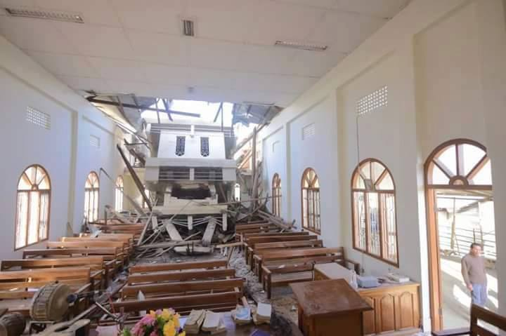
You do these things for CWM, all of our partners, and many others, all the time, and we are truly grateful. Because you give, our staff and partners are able to give:
In India, the Gospel Friends staff helped with rescue and recovery efforts in Manipur state following the January 4 earthquake.

