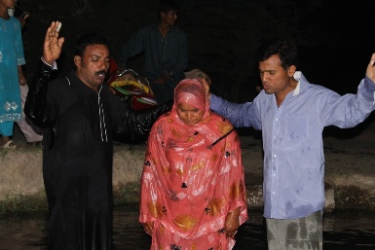
from family and difficulty in jobs and with the government. Pray for new believers to be firmly established in the Word and faith. A family here in the U.S. has offered to pay for seminary education for one of the young men in the church in Nepal. Pray for them, as he leaves his wife and child behind to study in the Philippines for another two years.


Youth Community Explosion kicked off again the first week of June with a wild water party. We have a great summer planned – camping, serving, exploring. We’ll be studying the names of God and how He reveals Himself and His desire to relate to us through His name.
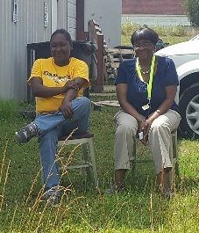
Our deepest longing is to see these young people come to know just how much God loves them, to see their lives transformed by His power, and to see them hungering for righteousness and seeking to follow hard after Him. Please pray for hearts to open wide.

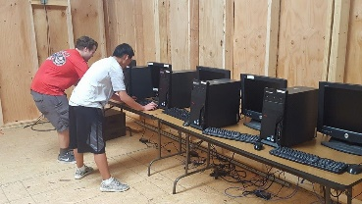
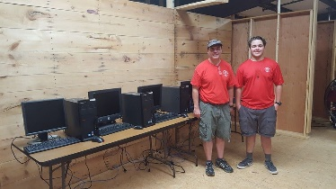
Also in the first week of June, Will Greene, a local teenager, installed 12 computers in our youth activity room. The computers were being phased out by Oktibbeha County Hospital (where Will’s dad works in IT), and Will asked if he could do this work as his Eagle Scout project. What a great blessing to us! Our youth will now have access to technology that is often not available to children in their circumstances.

It's a busy week, this first week of June! Lori, Christian, Ramzy, and I are all helping with Vacation Bible School at First United Methodist Church in Starkville. Actually, for the fourth consecutive year, this VBS is designating their mission offering to our international ministries. This time, we are focusing on providing clean water in Nepal and India, and each evening, we have had a demonstration of a sand filter, and an opportunity for the children to pound yams (actually, it’s just dough), husk rice, and carry two buckets of water on their shoulders.

At the close of each class, we remind the children what Jesus said, “Everyone who drinks this water will be thirsty again, but whoever asks for the Living Water that I give will never thirst. Indeed, the water I give him will become in him a spring of water welling up to eternal life.” (John 4:13-14)

Everything we do is done to lead people to Living Water, to Jesus. Pray for us. Pray for our partners around the world. Pray for God’s provision, for courage and strength, and for victory in every challenge we face. How grateful we are that you walk this road with us!

Blessings,


