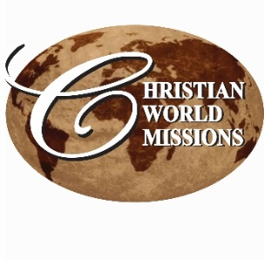
P.O. Box 985, Starkville, MS 39759
PRAYER NOTES & MINISTRY OPPORTUNITIES:

WEEKLY LOCAL MINISTRIES:
Men’s Prayer Breakfast
Friday, 6:30 am
CWM Outreach Center, Cecil Williamson
Youth Community Explosion
Daily, Mon, Tues, Thur, 8:30 – 1:30
CWM Outreach Center
June 6 – July 14

MINISTRY EVENTS:
Aug. 12-14 Lucedale, MS, UMC; Life in the Spirit Seminar

Sep 21-23 Nashville, TN;
New Room Conference

NEPAL/INDIA October 10-31

PRAYER NOTES:
- India – continuing financial needs; new students in Gospel Friends schools
- Starkville – the youth in our daily program; challenges are great!
- Starkville -- Funds to complete construction of community outreach center (approx.. $110,000);
- Pakistan – funds for completion of church and for children’s school fees
- Cecil Williamson – still recovering from back surgery
- Tiffany Ward – new baby girl born 2 months early, weighing 1 lb 15 oz. Mom and baby gaining strength daily.
Local volunteers needed!
Construction, Mentoring & Tutoring, Organization Projects

See our website for event details:
http://www.christianworldmissions.org/news-and-events/ministry-eventsmissions/

To schedule a ministry event, order resources or join us on a mission trip:

Contact:
leeann@christianworldmissions.org
lori@christianworldmissions.org
info@christianworldmissions.org
brittany@globalcl.org

JUNE 2016

Summer is definitely here, and with it, the start of new things all around the world in Christian World Missions. While our ministries all around the world are continuing to grow, with ever-increasing fruit for the Kingdom, we are facing serious challenges.

As you know, I was asked not to come to Nigeria this year because of kidnappings and murders in the region where we were to work. The situation there is still critical, and so our leadership is considering a new, more subtle approach to church-planting in that area. You may have read recently of the violent persecution against Christians in Kaduna state. Please pray for our brothers and sisters in Nigeria to stand strong in the Lord.

In India and in Starkville, we are facing critical financial need. Please consider making a generous gift above and beyond your regular donations. I am praying for 1000 people to make two extra or new gifts of $100 by year end. This would greatly relieve the burden of all of our partners around the world, but in India and Starkville are facing the most immediate needs.

Ghuna Kumar is struggling to meet monthly salary obligations and pay their electric bill (which also powers the pump for their water source), and we are nearing completion of building renovations and need to pay the sub-contractors.
Pray that God would raise up an army of supporters for all of our partners.

Great things are happening, and there is much for which to give thanks:

A new schoolyear has begun in India, and students are gathering at the Living Hope campus for elementary and secondary, paramedical, and Bible college courses. Please pray for new students and professors as they work together to prepare themselves for ministry across that great land.

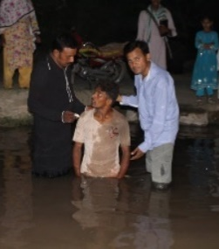
There have been a number of baptisms in Nepal and Pakistan recently, which is quite significant, since in both countries, baptism represents a conversion from another religion and commitment to Jesus Christ. It also could mean ostracism

