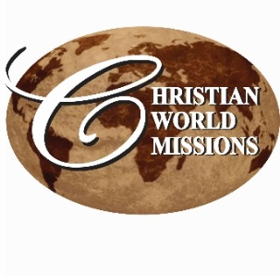
P.O. Box 985, Starkville, MS 39759
PRAYER NOTES & MINISTRY OPPORTUNITIES:

WEEKLY LOCAL MINISTRIES:
Men’s Prayer Breakfast
Friday, 6:30 am
CWM Outreach Center, Cecil Williamson
Youth Community Explosion
Daily, Mon, Tues, Thur (Begins Feb 8)
CWM Outreach Center
Lenten Bible Study
Begins February 11, 12 pm, CWM Outreach Center, Ends March 24

MARCH
22 – Family Easter Dinner – North Starkville Outreach – Outreach Center

APRIL
16-17 – Eureka, IL, UMC
Weekend of Renewal & Concert

30 – MAY 1 – Ladies’ Day Apart and Sunday Services, Picayune, MS FUMC

PRAYER NOTES:
- John & Christine in Pennsylvania;
- Our youth to love and follow Jesus
- Provision for a new van (approx.. $15,000)
- Funds to complete construction (approx.. $110,000);
- Fruitful evangelism in Ghana, Nigeria, India, and Pakistan;
- Peace & provision in Nepal
- Cecil Williamson’s recovery from back surgery
- Staff: Brittany, Tiffany, Delores, Rosella, Lori,
Lee Ann
- Interns & volunteers:
Taylor, Jamar, Robert
- International Partners: Ghuna, J.K., Joseph, Asif, Lydia, Ganesh, & Sunita

Local volunteers needed!
Construction, Mentoring & Tutoring, Organization Projects

See our website for event details:
http://www.christianworldmissions.org/news-and-events/ministry-eventsmissions/

To schedule a ministry event, order resources or join us on a mission trip:

Contact:
leeann@christianworldmissions.org
lori@christianworldmissions.org
info@christianworldmissions.org
brittany@globalcl.org
tiffany@globalcl.org

March 2016

Hope you are enjoying a taste of spring! I love seeing the flowers start blooming and the trees budding. Nothing like it. Enjoy! Spring brings new life and hope to all!

Every season in life leaves a mark – sometimes good, sometimes great, and sometimes catastrophic. We’ve just come through a season that had elements of all three, and we stand in wonder and awe as we watch God work all things together for good!
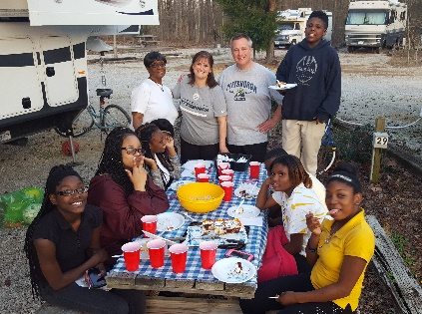
John and Christine Zimmerman from About Face Church Outreach Consultants, joined us at CWM for the entire month of February. They worshipped with us in several local churches, attended Bible studies, taught and played with our youth, and generally challenged all of us to build relationships with all we can so that at least some can come to know Jesus. They were not the catastrophe, but a definite catalyst for a great move of God among us.

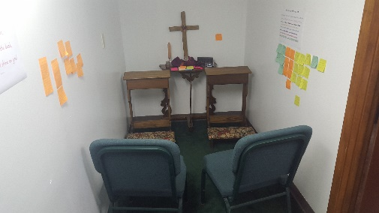
Just before they arrived, we transformed a supply closet into a “War Room,” a place where we can go for intentional time with the Lord, standing firm against the devil’s schemes, and calling down the powers of heaven to save, heal, deliver, and provide. Then, Christine challenged us to consider a weekly day of prayer and fasting, and to lay claim to our city in the name of Christ Jesus, praying on site for God to break through darkness and shine His light.

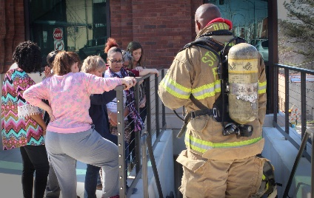
On Friday, February 19, we had our first day of prayer and fasting. Standing between two of the local United Methodist Churches, we asked God to bring His people together for His purposes. We also raised our hands toward the windows of the City Building Department asking for favor to be able to proceed with construction of our outreach center. A single roadblock has threatened to bring the entire project to a halt.

From there, we walked up the block to stand on the front plaza of City Hall. While we were there, fire alarms went off, and once the firemen had secured the building, one of them joined us in prayer for about 15 minutes! We all experienced the power of God that day and knew that something had happened in the heavenlies.

