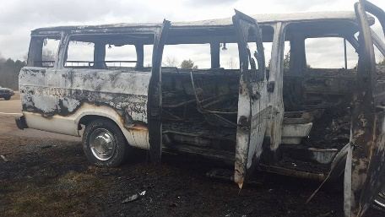
The very next day, our youth were on the way to a one-day retreat when our 15-passenger van caught fire. Everyone escaped safely, but the van was a total loss. It was a traumatic experience for all of us, even those who were not in the van. As most of the youth were panicking, one of the girls spoke up and said, “Y’all, we are so blessed. Nobody was hurt and God is with us.” She expressed what all of us felt. If you’d like to see a video of the fire, go to https://vimeo.com/156341359

We went on to have a wonderful day exploring the meaning of God’s unconditional love for us. On Tuesday, when they gathered again for regular programming, we took time to share our thoughts and hearts, drawing pictures about what the experience had been like for us. Each of us had the opportunity to examine our relationship with the Lord. Having discovered first-hand that life is full of the unexpected, we all needed to make sure we are right with the Lord and are following Him with all of our hearts. A near catastrophe turned out to be a wonderful blessing.

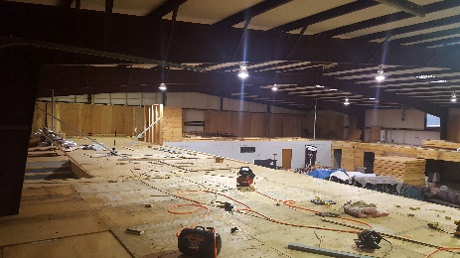
The roadblock to the local construction is the requirement for a licensed commercial general contractor. We have had great difficulty finding someone willing to take on this role, since much of our work is being done by volunteers. On two separate occasions, we thought we had secured someone only to have it fall through. The Monday following our first day of prayer and fasting, I went to talk with the City Building Department and asked them if there was anything they could do to help us keep moving forward. Less than 24 hours later, I received a phone call: they had worked it out in our favor, and 24 hours after that, we had every permit we need to complete the construction. Only God could work such a miracle! We are now ready for electricity, heating & air-conditioning, and the sprinkler systems to be installed!

Another great blessing is the gift of some 2 dozen computers. The local hospital, Oktibbeha County Hospital, has been replacing all of their computers and they give the functioning older ones to other non-profits. One of the tech managers’ sons is working on his Eagle Scout badge, and for his project, he will be installing a full system for our youth program! We need some new “desks” build for them, so if you’re looking for an easy project that will make a big difference…

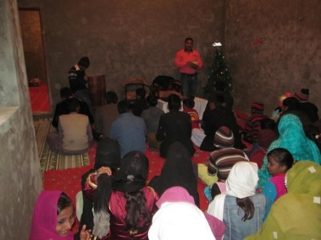
Meanwhile, I was working on final details for the mission trip to Nigeria and Pakistan. When I continued to run up against roadblocks to Pakistan, I realized the Lord was preventing my going this year. Less than a week later, I received news from Nigeria that violence had broken out in the area where we were to go, and they preferred that we not come since they could not protect us. I had already decided not to go to Ghana, but church planting will still go forward through leadership of J.K. Udeze in Nigeria, and Joseph Otsin in Ghana. Be sure to pray for the African nations and Pakistan. All are in times of great hardship. Pray that God’s Kingdom will prosper in this season!

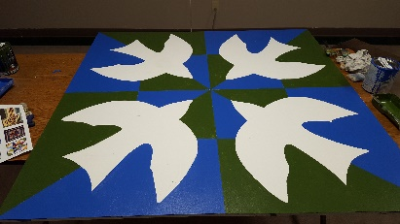
The local work in Starkville is at a critical time. I need to be here, but I was reluctant to “neglect” our partners overseas. As Solomon says, “Man makes his plans but the Lord directs his steps.” So, here I am in Mississippi, at just the right time to help pray and fast for the Kingdom to expand here, for a new van for our youth, and for adequate financing for the completion of our building. Pray with us as we launch new programs for parents and seniors.
One of four barn quilts volunteers recently painted for our building – welcoming the Holy Spirit!
Last Friday, we prayed between and marched around the local school district administration and the junior high school, and then prayed on the MSU campus. This week, we will be praying for another church and school, and then for a sister outreach to the poor that has experienced several break-ins over the last 2 months. We will also continue to pray for our international partners.

Our nation is in a difficult season. I am convinced that unless Followers of Christ are actively involved in building relationships with those in the most challenging circumstances, we will not see a turn-around in our culture. The Lord positioned CWM geographically in a part of our city that desperately needs the Gospel. We are in a new season. The Spirit of God has been released in and through your Christian World Missions staff around the world in new and powerful ways. Please pray with all your heart that many will come to know Christ.

Blessings and love,
