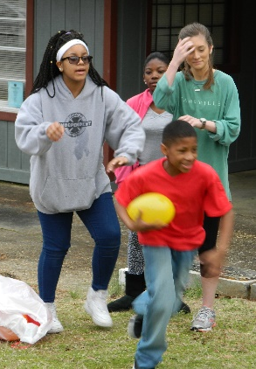
We also said goodbye to Taylor (on the right) , who interned with us from the MSU School of Human Sciences. She graduates on May 7, and was a great blessing to us. As she said, she learned that she is not called to work with junior high students (tahahaha!) but that this was the best work environment she has ever had and she learned a tremendous amount while with us.

We also said goodbye to two other young men, students who spent 3 months with us getting field experience for their courses. The Department of Human Sciences at Mississippi State has become a great partner. With courses in human development, they have quite a few students pass through their halls who are heading into fulltime ministry. What a joy for us to be able to spend a few months with them, learning and growing together!

We received these pictures from our partners this month, showing the mighty things God is doing to expand His Kingdom on the earth:
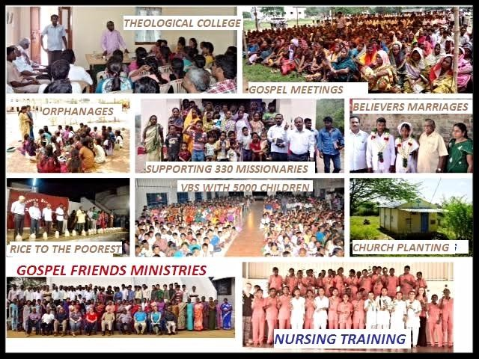
So much has happened in India, so many lives touched, changed, trained, sent. Gospel Friends is growing continually and is currently experiencing about a $12,000/month shortfall in income. If you can increase your giving to them, or encourage others to help, it would greatly relieve the pressure that financial worries bring.

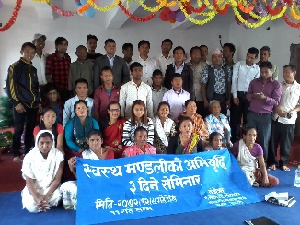
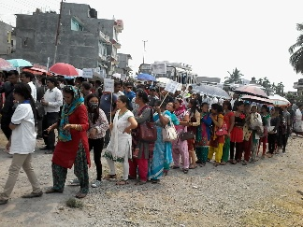
Christians gather every year in the Dhankuta Ecumenical District of Nepal to hold an Easter Procession through the streets. Many Hindus are coming to know Christ these days. The next picture shows a recent youth seminar to which students may bring their Hindu friends to come and hear the Gospel in a fun and transforming environment.

Please be praying this month for Sir J.K. Udeze in Nigeria as he leads the church-planting mission. It was postponed due to violence and kidnappings in the region, and we are praying that God establishes an even stronger presence of His Body as a result of the upcoming mission.

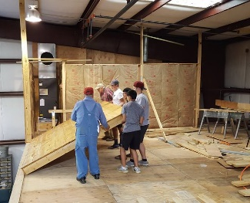
We also covet your prayers for our ministry here at home. After a one-month break, which began May 6, we will resume Youth Community Explosion for the summer on June 6. Please pray for our young people. They face so many challenges in their home environments. Sometimes, it’s difficult to see that we are making much difference, but God… Also pray that funds come in on time for us to complete construction on our community/conference center. We are close to being finished, but still need approximately $100,000 to finish the project debt-free. So much good ministry is already taking place here; pray that we can continue to expand our outreach as the building is completed.

We couldn’t do anything without your prayers and support. Thank you for your faithfulness. God is good! God is great! Let us thank Him for His grace! Amen!

Blessings and love,


