
P.O. Box 985, Starkville, MS 39759
PRAYER NOTES & MINISTRY OPPORTUNITIES:

WEEKLY LOCAL MINISTRIES:
Men’s Prayer Breakfast
Friday, 6:30 am
CWM Outreach Center, Cecil Williamson
Youth Community Explosion
Daily, Mon, Tues, Thur, 8:30 – 1:30
CWM Outreach Center
June 6 – July 15

MINISTRY EVENTS:
Aug. 12-14 Lucedale, MS, UMC; Life in the Spirit Seminar

Sep 21-23 Nashville, TN;
New Room Conference

NEPAL/INDIA October 10-31

PRAYER NOTES:
- India – continuing financial needs; new students in Gospel Friends schools
- Starkville – the youth in our daily program; challenges are great!
- Starkville -- Funds to complete construction of community outreach center (approx.. $110,000);
- Pakistan – funds for completion of church and for children’s school fees
- Cecil Williamson – still recovering from back surgery
- Tiffany Ward – new baby girl born 2 months early, weighing 1 lb 15 oz. Mom and baby gaining strength daily.
Local volunteers needed!
Construction, Mentoring & Tutoring, Organization Projects

See our website for event details:
http://www.christianworldmissions.org/news-and-events/ministry-eventsmissions/

To schedule a ministry event, order resources or join us on a mission trip:

Contact:
leeann@christianworldmissions.org
lori@christianworldmissions.org
info@christianworldmissions.org
brittany@globalcl.org
tiffany@globalcl.org

MAY 2016

Summer is definitely here, and with it, the start of new things all around the world in Christian World Missions:

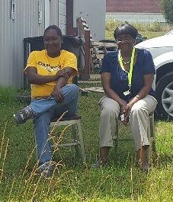
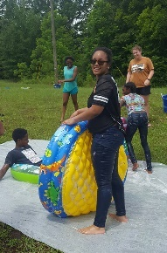

Our youth program kicked off again this week with a wild water party. We have a great summer planned – camping, serving, exploring. We’ll be studying the names of God and how He reveals Himself and His desire to relate to us through His name. Our deepest longing is to see these young people come to know just how much God loves them, to see their lives transformed by His power, and to see them hungering for righteousness and seeking to follow hard after Him. Please pray for hearts to open wide.

The Lord has sent us several interns this summer. Torrey Dale is majoring in Maggie is

A new schoolyear has begun in India, and students are gathering at the Living Hope campus for elementary and secondary, paramedical, and Bible college courses.

